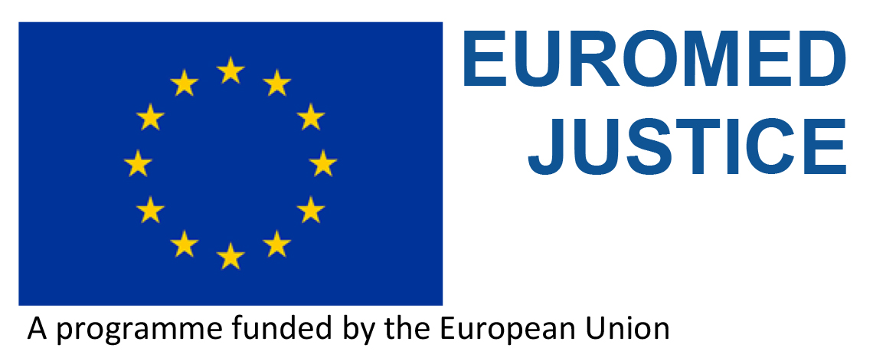

*The EuroMed Justice IV is currently in its inception phase and will be implemented over a period of three years. With a view to paving the way for a successful project implementation, several missions have already been carried out in Europe to numerous institutions/organisations operating in the field of justice. The Project Management Team is now carrying out a series of missions to the South Partner Countries.*

**Overall objective**

The overall objective of the Euromed Justice IV project funded by the European Union is to contribute to the development of a Euro-Mediterranean area of effective, efficient and democratic justice system respectful and protective of human rights by the strengthening of the rule of law and continuously progressing towards the alignment to international legal frameworks, principles and standards. This project of regional scope is addressed to the European Neighbourhood South Partner Countries (ENI SPC).

Overall, the Euromed Justice IV project seeks to consolidate and further develop the achievements of Euromed Justice I, II and III.

**The South Partner Countries**

The partner countries are the People’s Democratic Republic of Algeria, the Arab Republic of Egypt, Israel, the Kingdom of Jordan, Lebanon, Libya, the Kingdom of Morocco, Palestine and the Republic of Tunisia.

The Syrian Arab Republic’s participation is suspended by decision of the EU.

**Main themes covered**

The Euromed Justice IV project will more particularly address issues related to the themes of

1) **Effective independence of justice and access to justice services**, and

2) **Regional cooperation on private and criminal law**.

**Purposes**

* To support, building on recent changes and on a flexible and demand-driven

approach, relevant reforms of the justice system in the SPC;

* To foster effective coordination and cooperation between the SPC and the

European Union in the area of justice;

* To strengthen cooperation between the countries of the Region as well as with the European Member States and Agencies;
* To provide capacity building in priority areas, based on the identification of needs and gaps and promote the sharing of existing expertise and good practices;
* To provide a dialogue platform on justice and security issues;
* To establish a linkage with EuroMed Police IV;
* To create an inter-professional community of magistrates and lawyers.

**Novelties of Euromed Justice IV compared to previous phases**

1. **Flexibility**. Flexible and demand-driven approach. Needs analysis and priorities to be established in partnership with the SPC. Creation of a Technical Assistance Facility (TAF) represents the core feature of this new approach.
2. **Differentiation**. SPCs are not facing the same challenges and do not have uniform needs. Therefore, in some areas and activities a bilateral or sub-regional approach might respond better to the aims of the project even within the regional framework.
3. **Sustainability**. Connecting the programme more firmly to permanent frameworks aiming for closer institutional relations. In this context, it will strive to foster/support judicial cooperation networks.
4. **Coordination** with European and international organisations operating in the areas covered by the project (i.e. Eurojust, European Judicial Network, Europol, etc.) as well as with EuroMed Police IV. The aim is to avoid duplication and look for synergies.
5. **Horizontal issues**. Rights-based approach, women empowerment, protection of vulnerable persons.

**Target groups**

The project targets the judiciary, prosecution, judicial training institutions and justice staff, Ministry of Justice, independent judicial institutions Bar associations and institutes for training of lawyers, other legal professionals, university research centres and academics, civil society organisations (NGOs active in the justice sector), and the media.

**The Consortium**

The project is managed by a consortium led by the *Fundación Internacional y para Iberoamérica de Administración y Políticas Publicas –* FIIAPP (Spain). The other consortium members are: the Center for International Legal Cooperation – CILC (the Netherlands), the European Institute of Public Administration – EIPA (the Netherlands), and *Justice Coopération Internationale –* JCI (France).

**The Team**

The team leader is Ms Maria Victoria PALAU TÁRREGA, experienced manager of international projects. She is assisted by two key experts: Mr Virgil IVAN-CUCU, Capacity-Building Expert, former senior judge and prosecutor, European Centre for Judges and Lawyers, EIPA Luxembourg; and Ms Dania SAMOUL, Project Coordinator, former Coordinator of the EuroMed Justice III project.

The project office is at EIPA Barcelona.

C/ Girona, 20,

ES-08010 Barcelona

Tel. 34 93 245 0904/05

e-mail:

[victoria.palau@euromed-justice.eu](mailto:victoria.palau@euromed-justice.eu)

[virgil.ivan-cucu@euromed-justice.eu](mailto:virgil.ivan-cucu@euromed-justice.eu)

[dania.samoul@euromed-justice.eu](mailto:dania.samoul@euromed-justice.eu)